|  |
| --- |
|  |
| PMIS – Projex Redesign |
|  |

|  |
| --- |
|  |

Team 43

40432720

40428196

40435293

40444263

40288696

Contents

Project Summary 2

Dates 2

Purpose 2

Targets 3

Major Risks 3

Roles 3

Business Case 4

Business Purpose for doing the project 4

Expected Benefits 4

Expected Dis-Benefits 4

Expected Cost 4

Configuration Map 0

Schedule Model 0

RIC Register 1

Progress Register 3

# Project Summary

## Dates

|  |  |  |
| --- | --- | --- |
| Sponsor Appointed | Project Authorized | Project Closed |
| 20/01/2020 | 23/01/2020 |  |

## Purpose

|  |  |
| --- | --- |
| Goal / Outcome | The purpose of this project is to redesign Projex entirely from the students' point of view to try and make the process less intimidating. The idea is to streamline the team formation process with a particular focus on an improved UI, additional guidance and improved communication among students, clients and the faculty.  The app will take in the details, skills and other inputs from student users using an improved UI. The app will show the student user projects (in an improved UI) suited for their skills as a priority with less suited projects appearing further down the screen. The student will be able to see other students interested in the project to then communicate and form teams.  The Team formation UI will include a team profile entry to showcase the team’s strengths to potential clients along with guidance for getting a successful bid on a project.  Both external and internal users will be able to create projects. The external user will be able to place notifications for when they are going to be present on campus or how to contact them for further details about their project.  The app will provide forums on how to handle certain situations to try and make group projects easier to handle and to share advice/help with other users. Other forums will include advice on how to set up group projects yourself, advice on getting over personal and social inhibitions, a page for user testimonies on group tasks. There will be links provided in the app taking the user to various pages on the Edinburgh Napier University website to find help regarding student well-being as well as other useful contacts.  The app will allow an admin user to have admin rights across all the app (adding, removing and verifying users/projects, teams, adding and removing forums). The results of the project will be used by the School of Computing to improve their version of the system for next year's students.  If there is enough time after the above items have been implemented into the app then the following features will have a possibility to be implemented into the project.  A rebranding of Projex to try and make it more aesthetically appealing to the users. This will be done through consultation with Edinburgh Napier University’s faculty to ensure that it is to their approval and standards.  A synchronous message update board will be implemented for the user to see about any updates provided by admin. These updates will also appear as posts on the main page of the app and in the forums section of the app.  The redesign will not produce a new app for the user but will instead be an update. The update will not introduce any autonomous aspects to the team building process, nor will it change the processes set in place by Edinburgh Napier University. |
| Main product | Prototype of Projex redesign |
| High-level Requirements | Development server |

## Targets

|  |  |
| --- | --- |
| Duration | 12 weeks |
| Budget | n/a |

## Major Risks

|  |
| --- |
| The major risks identified in the RIC are the loss or corruption of the data files containing the Projex data, security breaches, poor communication within the team and with the sponsor. |

## Roles

|  |  |
| --- | --- |
| Sponsor | Brian Davison |
| Consultants | n/a |
| Project Manager | Jon Robinson |
| PM Support(s) | Karen Stewart, Tolu Ademuwagun, Nicolas Obara, Gregoire Arnoult |
| Team Manager(s) | n/a |
| Supplier PM(s) | n/a |

# Business Case

## Business Purpose for doing the project

|  |
| --- |
| The live version of Projex has room for improvement. The live version is daunting, time consuming, places undue stress on students and does not encourage students to proceed further in their studies or in preparation for group task.  The live version also has some bugs in the UI, is missing its potential to guide users and to implement Edinburgh Napier University links such as The Bright Red Triangle and student wellbeing and support. The app can also improve communication between students and faculty with the implementation of forums and synchronous communication on the app.  The redesign is aimed at addressing these issues by improving the UI and the User experience |

## Expected Benefits

|  |
| --- |
| Future users of Projex will have a more streamlined experience finding a team, project and communicating with potential clients and peer students. Users will also have an easier experience setting up their account to find projects. Student users should expect to feel less daunted using Projex after the redesign. Admin will have a better experience helping students to find teams, projects and to communicate with clients. |

## Expected Dis-Benefits

|  |
| --- |
| To the teams knowledge there are no practical, ethical or business dis-benefits to this project being carried out. |

## Expected Cost

|  |
| --- |
| n/a |

# Configuration Map

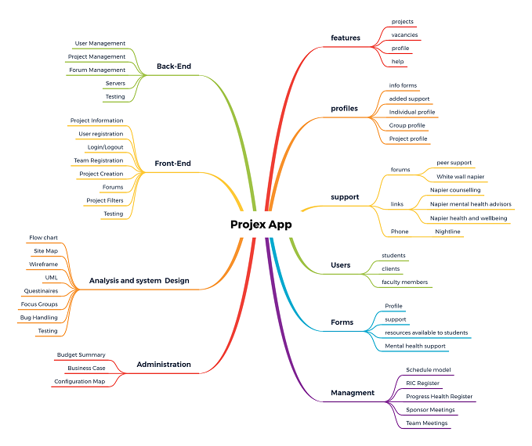

# Schedule Model

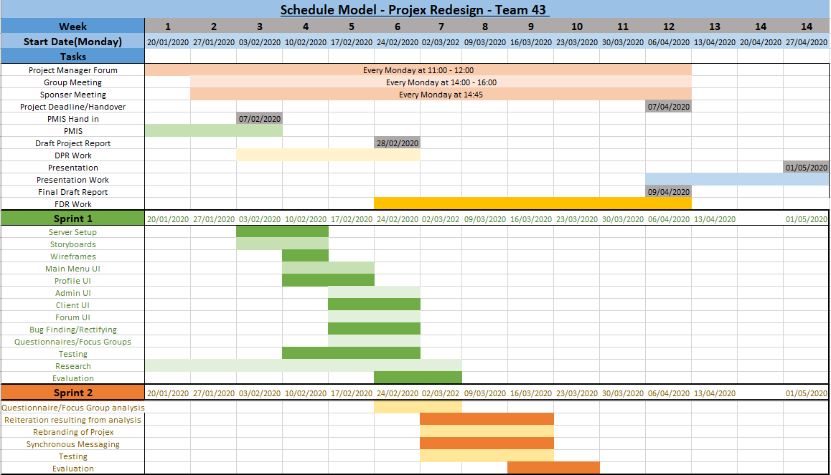

Sprint 3 will occur if the evaluation at the end the end of Sprint 2 concludes that more work is needed. Sprint 3 would conclude before the end of week 11.

# RIC Register

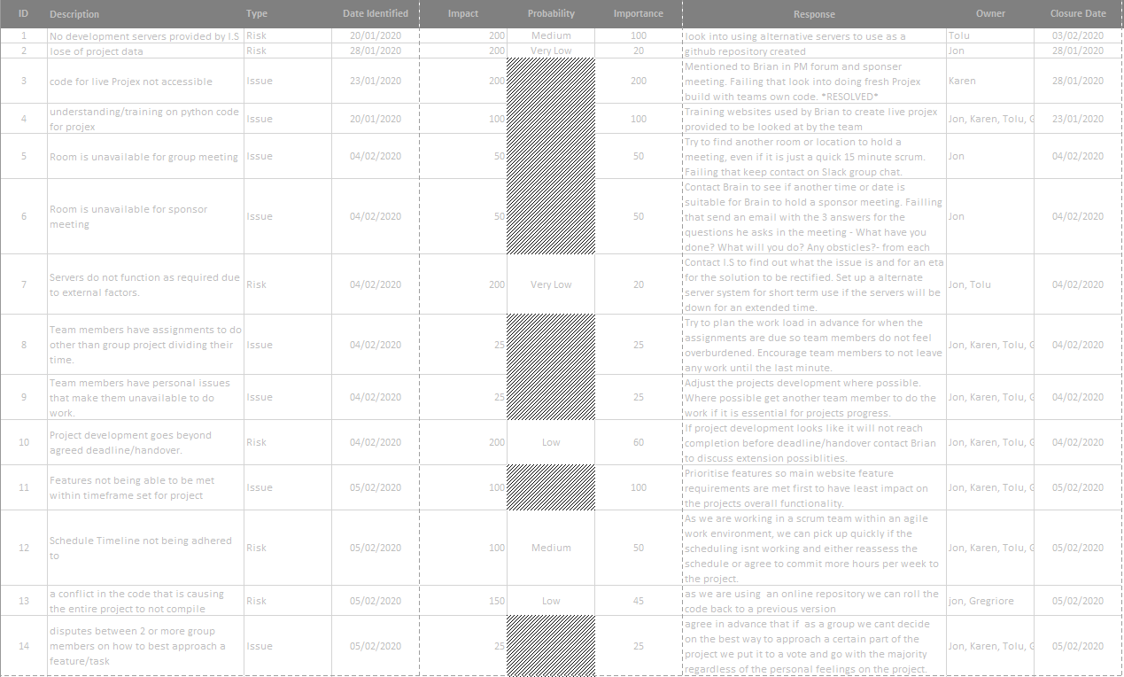

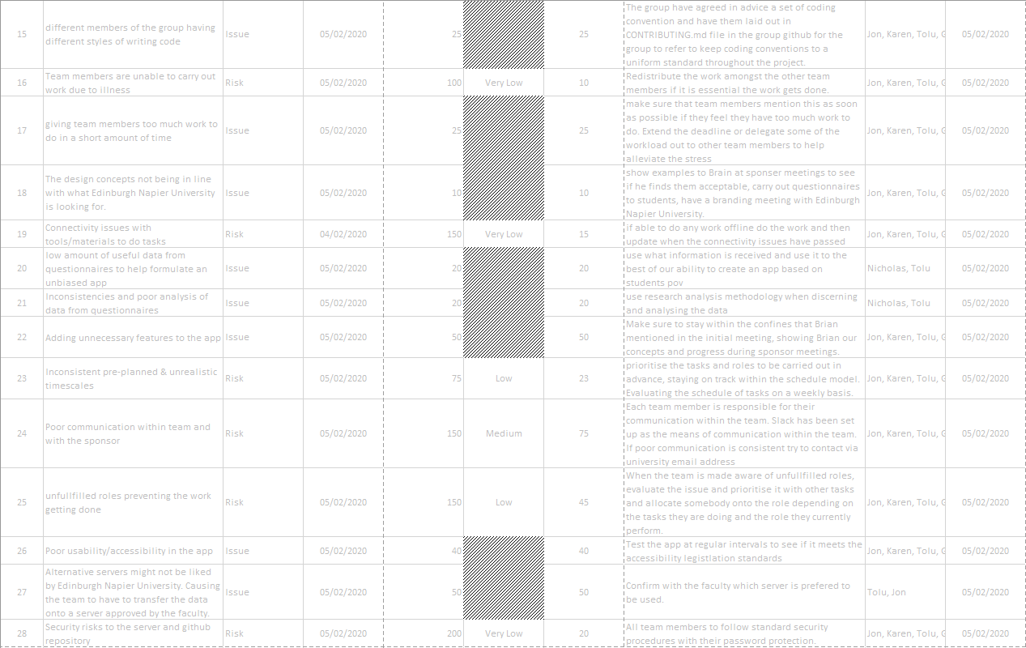

# Progress Register

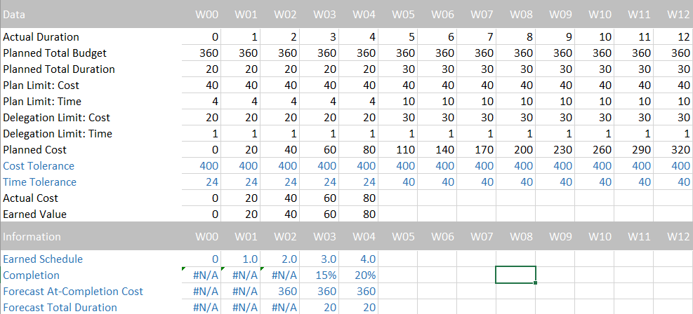

The data provided is a best guess estimate the week before the start of development and will be updated if needed.